[RYERSON UNIVERSITY](http://www.ryerson.ca/index.html)

Department of Electrical and Computer Engineering

Faculty of Engineering and Architectural Science

|  |
| --- |
|  |
| Low Power SAR CubeSat |
|  |
| EDP Project Report – Fall Semester |

Authors: [Bethany Santos, Ho Yin Samuel Yeung, Owais Nakhuda]

Faculty Lab Coordinator: [Krishna Kumar, BSc, MS, PhD]

December 2, 2018

Index

Index 2

Abstract 5

Introduction 7

Objectives 8

Theory 9

Synthetic Aperture Radar (SAR) 9

Preliminary Design 12

Gantt chart: 21

Appendices 21

References 22

# Abstract

The goal of the design project was to design a cubesat to perform useful work sought by professional space research institutions (NASA, JPL, CSA, etc.). The following report describes the general design approach that will be taken for both a biomedical research payload and a low power Synthetic Aperture Radar Payload (SAR). However, due to resource constraints, the main purpose of the report is to outline the design of a Low Power SAR imaging Satellite.

The effects of prolonged exposure to low gravity and high radiation on living organisms are important to understand in order to keep current astronauts in good mental and physical health. While many of these experiments are typically conducted by the scientists on the satellites, due to the difficulty of conducting experiments in actual space, there is a need for equipment that can remotely perform the same experiment with the exposure to high radiation and environments. Therefore, specialized satellites such as NASA’s ecAM Sat are needed. However, due to the size constaints, and the heavy equipment required for microbiology, these satellites consist of mainly microfluidic plate assemblies, and a method of binary verification. In the case of the ecAM Sat, a simple dye was used in order to verify the sample had grown. Despite the simplicity of the setup, these satellites, such as the NASAs ecAMSAT and GENE-SAT1 were unable to reduce their footprint to less than 3U (10 x 10 x 30cm, 6W maximum available solar power). As a result, any further research into biomedical satellites would be in regards to optimizations in size and power. Due to the complexity of the required instruments and apparatuses, an immediate and disruptive design solution is not possible with the current available technology at the moment.

Radar Imaging techniques are a well-established method of surveillance and environmental research. They are used to provide modern weather data for meteorology, and surveillance. Synthetic Aperture Radar is one common technique used by imaging satellites. These satellites, such as CSA’s RADAR Sat 1 and 2, are able to form a high resolution (~1m resolution) 3Dimage of the earth after one full orbit. Despite the importance of such satellites, there has not been much interest in minimizing the power, size and weight of these devices. With the recent popularity of LoRa transceiver devices in consumer electronics, new methods of signal processing have allowed these low power communication devices have the ability to transmit across hundreds of km with only a few mW of transmission power. With proper design. This would give rise to a real-time full surveillance of the Earth. Therefore, the focus of our design project is to create a low power SAR cubesat for real-time global surveillance

Introduction

Climate change is a critical issue that affects the world on a global scale. As such, research into climate change requires data and instrumentation on a global scale. One such device used for gathering environmental data are Synthetic Aperture Radar satellites. According to a magazine article by Alberto Moreira and his associates,

*Synthetic Aperture Radar (SAR) has been widely used for Earth remote sensing for more than 30 years. It provides high-resolution, day-and-night and weather-independent images for a multitude of applications ranging from geoscience and climate change research, environmental and Earth system monitoring, 2-D and 3-D mapping, change detection, 4-D mapping (space and time), security-related applications up to planetary exploration. [1]*

One of the many benefits of SAR satellites are their ability to survey an area of the earth regardless of the conditions (i.e; visual obstruction by clouds, sunlight) making them an essential tool for real-time data acquisition. However, current SAR satellites in orbit are very old and have not been designed for lightweight and low power operations. These include Canada Space Agency’s own RADARsat1 and RADARsat2, as well as the CLOUDsat developed by NASA. According to the Government of Canada[20], the RADARsat1 and 2 were incredibly heavy satellites, each weighing well over 100kg. They were also very large units, spanning well over 225m2 in antenna surface area.

With the recent introduction of long range wireless technologies like LoRa, and CSS modulation, it is possible that the weight and size of these systems can be reduced a fair amount, while retaining their usefulness as remote sensing devices. Therefore, for our design project, we will be designing a SAR surveillance system, under the size, weight and power constraints of a standard cubesat unit.

A single cubesat satellite has the following design restrictions [23]:

* A 1U cubesat will weigh no more than 1.3kg
* A 1U cubesat must fit within a 10 x 10 x 10cm frame

In addition, onboard power will be supplied by solar panels. Therefore, the system must also be designed around the available power provided by solar panels.

# Objectives

The main goal of this project is to build a functioning SAR Imaging device that fits within the power and size constraints of a standard Cubesat. In order to accomplish this, 3 smaller goals must be completed to accomplish this task

1. Following the SAR Building Guide by MIT[5], build working SAR imaging framework
2. Optimize design for power, size and cost
3. Determine achievable methods of increasing range (antenna variations, allowable transmission power, operating frequency, etc.)

By the end of this project, a fully functional and self-contained SAR device should be built that is able to meet the size and power constraints of a standard cubesat.

# Theory

## Synthetic Aperture Radar (SAR)

Synthetic Aperture Radar (SAR) has been widely used for Earth remote sensing for more than 30 years. It provides high-resolution, day-and-night and weather-independent images for a multitude of applications ranging from geoscience and climate change research, environmental and Earth system monitoring, 2-D and 3-D mapping, change detection, 4-D mapping (space and time), security-related applications up to planetary exploration. [1]

In short, a moving radar beam is used to measure the height of the area in question. Depending on the frequency of radiation used, different data is gathered by the SAR device. The following are the most common bands used for imaging:

* Ka (25 – 40GHz) band: High resolution imaging
* Ku (12 – 17.6GHz) band: Snow Monitoring
* X (7.5 – 12GHz) band: High Res. Imaging, Snow and environment monitoring
* C (3.75 – 7.5 GHz) band: Ice monitoring
* S (2 – 3.75 GHz) band: Ice monitoring
* L (1 – 2 GHz) band: Biomass estimation (forestry, foliage)
* P (250 – 500) band: Biomass estimation (forestry foliage)

Depending on the processing, a 3D image at a certain point in time can be generated.

In general, the resolution of SAR devices is within a few meters. In general, the higher the frequency, the more precise the imaging becomes. However, due to the equation of system link budget[4]:

**PRX[dBm] = PTX[dBm] + Gsys [dB] – Lsys [dB] – Ich [dB] – M[dB]**

The required transmission power and receiver sensitivity increases greatly as losses in the channel increase. The losses in the channel are the most significant factor due to long operating range required by our satellite design (with low earth orbit being about 300km, of which the pulse must travel twice). According to the equation for freespace path loss [3]:

Therefore, we can assert that, the total power of the system depends greatly on the distance traveled and frequency of the wave. However, depending on the directivity of the antenna being used, and the signal processing, the transmission gain of the system can still be increased even if the power remains constant.

In regards to processing, Chirp Spread Spectrum Modulation is the common method of producing short pulses, or “chirps”, for transmission. *Chirp Spread Spectrum was developed for radar applications in the 1940’s. Traditionally used in a number of military and secure communications applications; over the past twenty years this modulation technique has seen increased adoption in a number of data communications applications due to its relatively low transmission power requirements and inherent robustness from channel degradation mechanisms such as multipath, fading, Doppler and in-band jamming interferers.[4]*

The “processing gain” achieved by CSS and LoRa Modulation can be determined by the following equation[4]:

Where Rchirp is the rate of chirp pulses, and Rbit the data rate of the bit stream being sent.

In addition to signal processing, antenna selection plays an important role in determining the efficiency of signal transmission. According to a paper by Roger Harrington, the maximum gain of the antenna can be calculated as follows[21]:

Where G is the gain, r is the distance of the antenna, P is the outward-directed complex power and Sr is the radical component of r. The Lora antenna would need a minimum of 20dBm gain to operate.

When designing the antenna for the SAR CubeSat the following equation was used to determine the length of the antenna:

Where c is the speed of light and f is the desired frequency. To further meet the specifications for the 10 by 10 CubeSat and to achieve a longer lobe to increase antenna range, a ¼ wave GP antenna will be used. This makes the length of the antenna 8.19 cm.

# Preliminary Design

The maximum transmitted power of an RF device operating at 915MHz is 36dBm (1W), according to the FCC. However, according to the Government of Canada:

*In the case of interference between licence-exempt radio users, it should be noted that such devices are frequently designed to share specially designated frequency bands in Canada, and therefore no one user has priority over another. For this reason, goodwill and a spirit of mutual cooperation is encouraged to resolve such interference problems. It should also be noted that even despite these efforts, effective solutions may not always be found as licence-exempt radio devices can vary greatly in usage and technical sophistication.[2]*

Therefore, for the purpose of this project, the maximum allowable transmission power will not be limited to 36dBm, and it will be assumed that the SAR device will cause minimal interference due to its directivity, and moving beam. With reference to the SAR design by MIT, Figure 1 shows the necessary components required in order to implement a Pulsed SAR device.

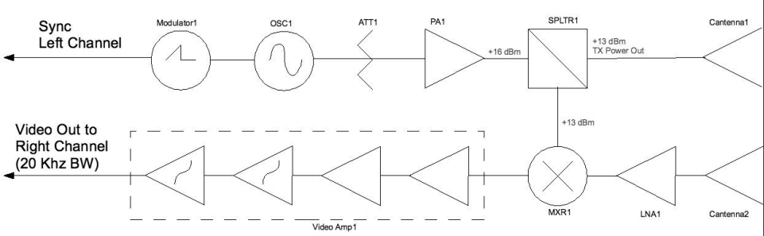

Figure 1 - General SAR Block Diagram

The diagram can be somewhat simplified by using a LoRa module as the signal source, and designing an ADC receiver that can pick up the echo.

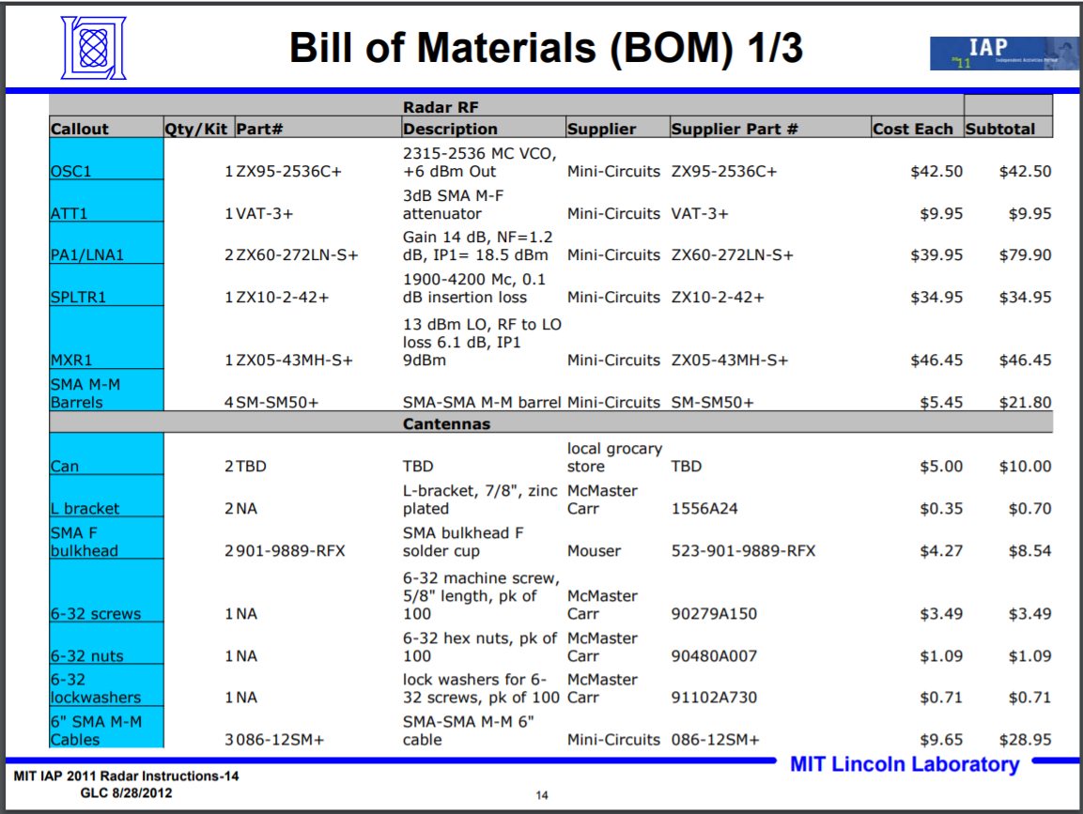

Figure 2 - Sample Bill of Materials for SAR Device

The Electronic circuit will consist of the six main subsystems: antenna, transceiver, digital signal processing, data acquisition and handling, microcontroller, and power. Figure 3 shows how they are correlated with each other in the most simplistic way. The antenna will be receiving and transmitting analog RF signals which funnels through the transceiver to be modulated/demodulated. The output is then sampled, manipulated and prepped for image processing by the DSP and the Data Acquisition and Handling subsystems. All ICs are controlled by a micro controller. The ICs chosen for this project are planned to be included in the build of the circuit; however, it may not end up in the final design due to testing adjustments, optimization, restrictions etc. All ICs operate below 3.6V and 100mA and are from well known and reliable suppliers. An overview of the IC’s specs and information is seen in Table 1.

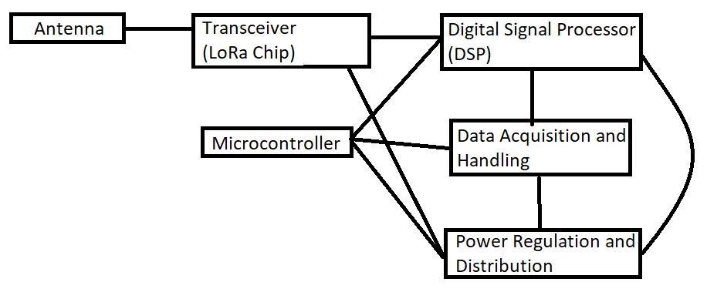

**Figure 3 – Subsystem Circuit Correlations**

|  |  |  |  |
| --- | --- | --- | --- |
| Manufacturer Part Number | TMS320C5535AZHHA10 | PIC32MK1024MCF064-I/PT | LTC3521EUF#PBF |
| Manufacturer | Texas Instruments | Microchip Technology | Linear Technology/Analog Devices |
| Description | IC DSP FIXED-POINT 144BGA | IC MCU 32BIT 1MB FLASH 64TQFP | IC REG BUCK BOOST ADJ TRPL 24QFN |
| Unit Price (CAD) | 10.66 | 11.34 | 10.66 |
| Part Status | Active | Active | Active |
| Type | Fixed Point | MIPS32® microAptiv™ | Step-Down, Step-Up/Step-Down |
| Voltage Input | 1.8V, 2.5V, 2.75V, 3.3V | 2.2 V ~ 3.6 V | 1.8V ~ 5.5V |
| Operating Temperature | -40°C ~ 85°C (TC) | -40°C ~ 85°C (TA) | -40°C ~ 125°C (TJ) |
| Mounting Type | Surface Mount | Surface Mount | Surface Mount |
| Package / Case | 144-LFBGA | 64-TQFP | 24-WFQFN Exposed Pad |
| Supplier Device Package | 144-BGA MICROSTAR (12x12) | 64-TQFP (10x10) | 24-QFN-EP (4x4) |

**Table 1 – Overview of ICs**

The transceiver in this design will be a LoRa module: SX1257 from Semtech. This transceiver will demodulate the RF signal into its in-phase and quadrature (I and Q) components; similarly, it will modulate I and Q signals components of a message and amplify the signal to be transmitted. Figure 4 shows the block diagram of the SX1257. According to the datasheet the variable amplifier for the transmitter (TX) pin is incrementable by 2 dB steps and reaches a maximum of approximately 38 dB [13] which may not suffice for the application of transmitting signals ~400km and back; therefore, if need be, an additional amplifier may be inserted in between the transceiver and antenna to increase transmit power. A suggested schematic for how the SX1257 pin will connect with other peripherals and passive components is seen in Figure 5.

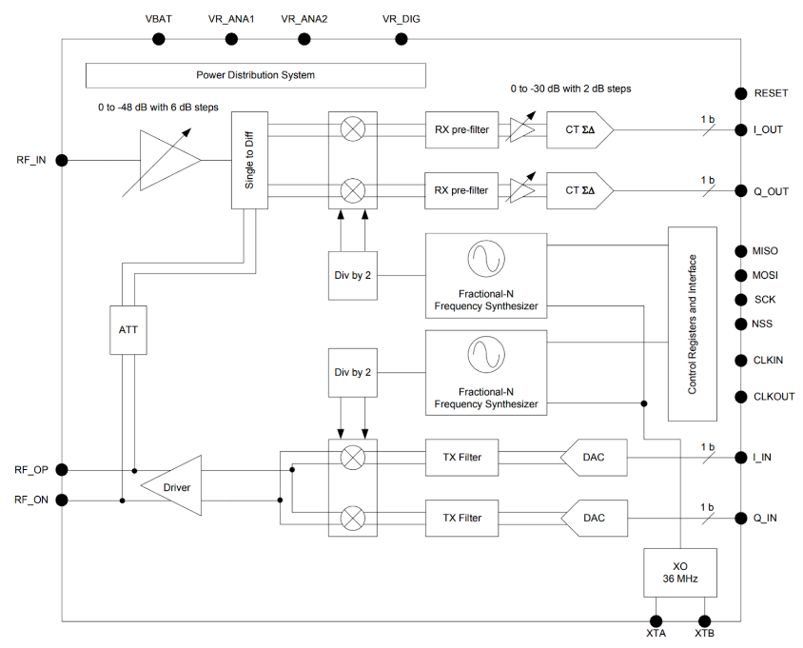

**Figure 4 – SX1257 Block Diagram**

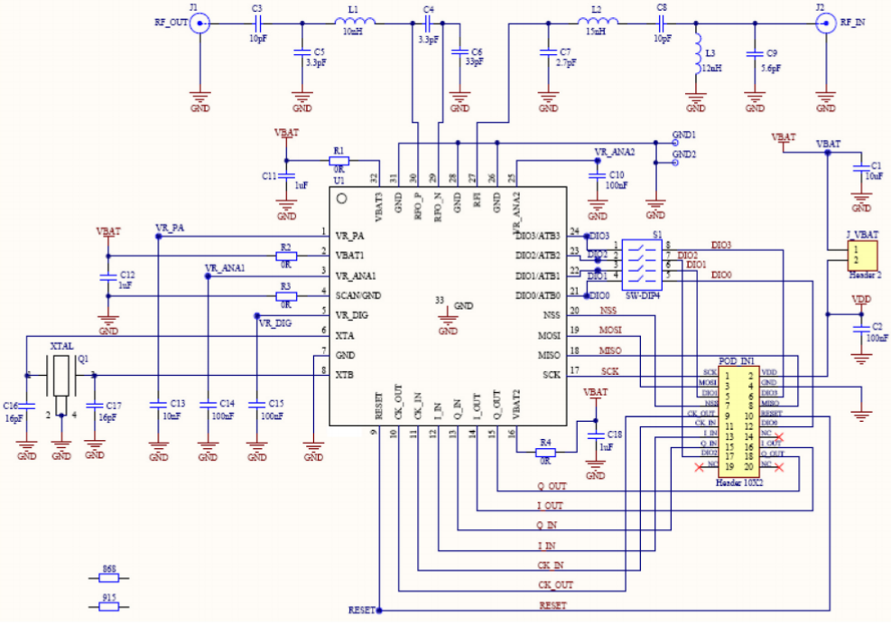

**Figure 5 – Sample Schematic for SX1257**

The I and Q components will then be fed in to the digital signal processor which will be sampled, converted to digital signals, and arithmetically manipulated to be prepped for data analysis and processing. The chosen IC for this subsystem is the TMS320C55 from Texas Instruments for its high performance and low power consumption. It includes two Arithmetic and Logic Units (ALU), 320KB RAM, and 128KB ROM [11] which is forecast to be enough for all SAR and RF signal processing in this application.

The power circuit will consist of two main system: power source and power distribution. The power source will mainly be supplied from Solar cells covering the body of the CubeSat. There are many suppliers that provide solar cells specific for CubeSat application fitted to accommodate the 1U CubeSat dimension and housing standards. The 1U Solar Panel from Endurosat will be used in the design supplying a maximum of 4.66V, 516 mA totalling to 2 watts per panel. This panels also include a sun sensor, magnetometer, and a temperature sensor. [10] In order to control the amount of voltage supplied to the ICs on the board, the LTC3521 adjustable buck/boost regulator from Linear Tech will be used as the main distribution gateway. This chip utilizes an organized arrangement of resistor ratios to control its output voltage ranging from 0.6V to 5.5V. [16]

Many of CubeSat projects have been built using a PIC microcontroller. For this design, the PIC32MK from Microchip Technology will be used. It is a general-purpose microcontroller but can be replaced by another microcontroller with a more SAR specific application.

The ICs needed for the Data Acquisition and Handling subsystem will be determined later during the build phase since, this subsystem may be already be programmed in the microcontroller or the Data Acquisition and Handling subsystems. For simplicity and PCB space management purposes, this subsystem will be left un determined for the time being.

The CubeSat housing will follow the NASA standard dimensions provided in the drawing below (Figure 8) [6]. Inside housing structure will have slots that will rack multiple PCB boards shown in Figure 6 [7]. There are several companies that sell 1U pre-designed structures such as ISISpace and Endurosat with prices ranging from 1,500 – 2,500 euro. This may not be a feasible purchase if the project budget does not permit it. Other available alternative is to construct the housing with 7025 Aluminum sheets which are corrosion resistant, strong, and doubles as a heatsink and machine it to follow design blue prints. In addition to the housing, permanent magnets and hysterysis rods may be inserted and mounted on to the frame of the CubeSat to ensure a constant angle or orientation relative to earth for the duration of its stay in Low Earth Orbit (LEO). This will also provide a more accurate calculation of power obtained from the sun. An example of how this might look like is shown in Figure 7.

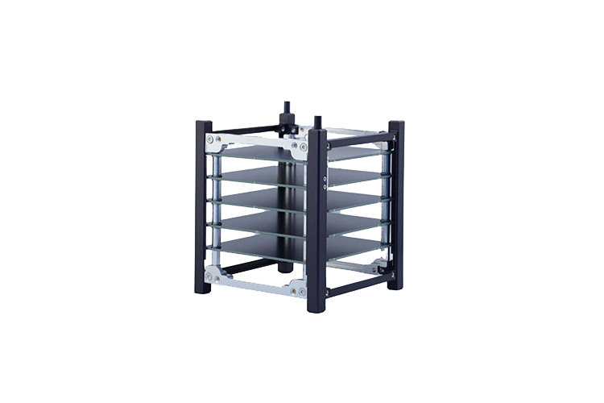

**Figure 6 – 1U CubeSat Structure [7]**

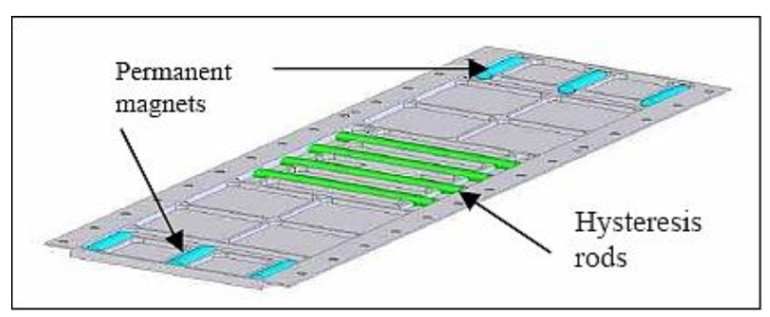

**Figure 7 – Positioning of permanent magnet and hysterias rods on CubeSat frame**

The CubeSat will be stacked in a launcher tube called the Poly-Picosatellite Orbital Deployer (P-POD) which can hold either one 3U CubeSat, one 2U and one 1U CubeSats, or three 1U cubesats. It is a standard deployment system that ensures CubeSat developers to conform to the standard physical requirements (*).

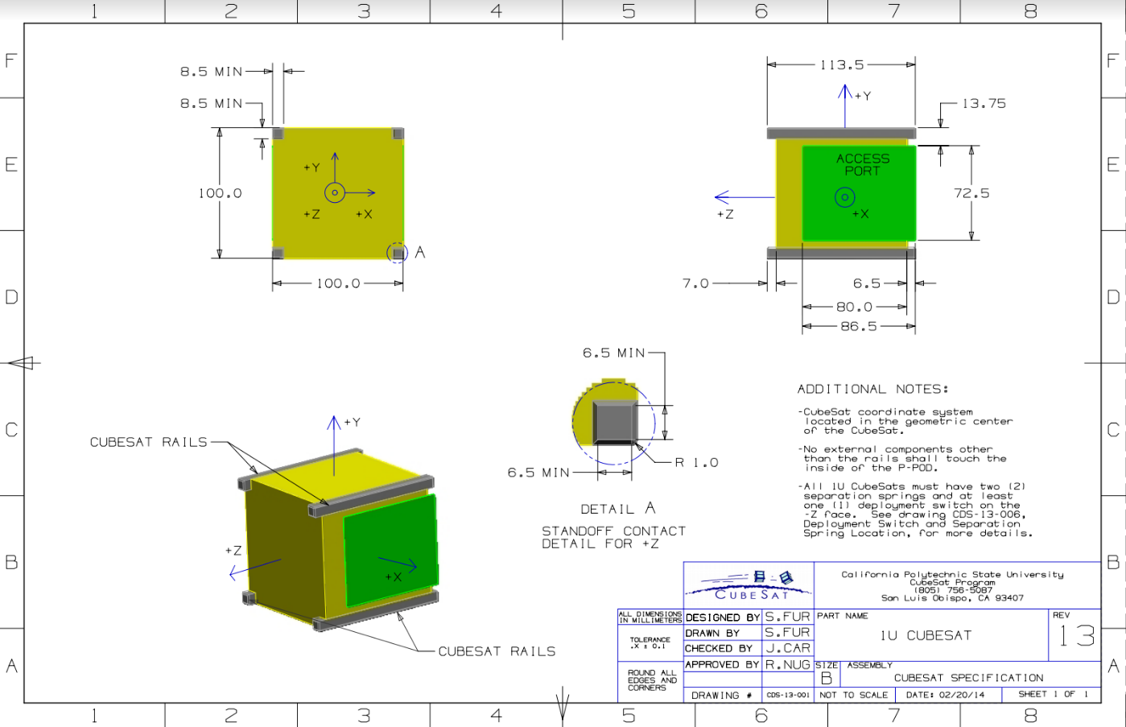

**Figure 8 – 1U CubeSat Drawings**

The microcontroller, LoRa module, DSP will be programmed in embedded C language. Python and MATLAB will be the main platform used to create a Graphic User Interface (GUI) for testing purposes. The GUI test platform will look like Figure 9 where live test results of received frequency signals and spectrogram will be displayed. [15] A sample software block diagram that utilizes MATLAB to compress SAR images is shown in Figure 10. [10] This example from MIT can be used for testing purposes as well.

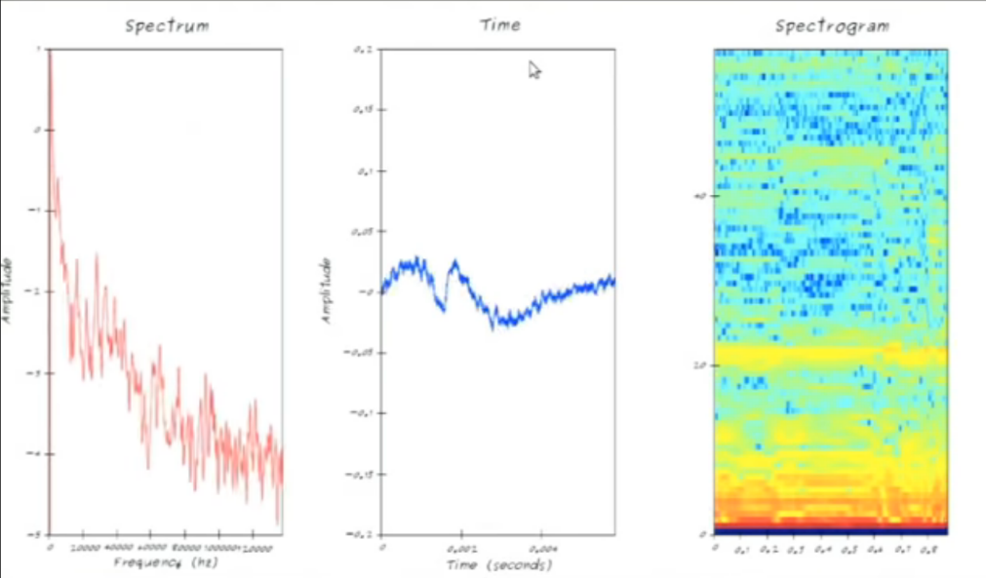

**Figure 9 – GUI Sample**

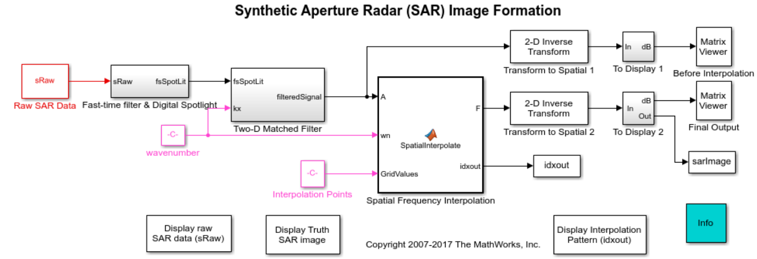

**Figure 10 – Software block diagram for SAR Image compression done in MATLAB**

The antenna design can be seen in figure 11. This design is chosen because of the short and thick antenna used to reach a frequency of 915 MHz. The antenna will be tuned by trimming the copper wire until a frequency of 915 MHz is reached. The weight of the antenna will also be decreased by using a lighter casing for the antenna and using a PCB board instead of the Arduino chip. To ensure optimal antenna performance the standing wave ratio (SWR) will be measured to ensure it is below 2[22].

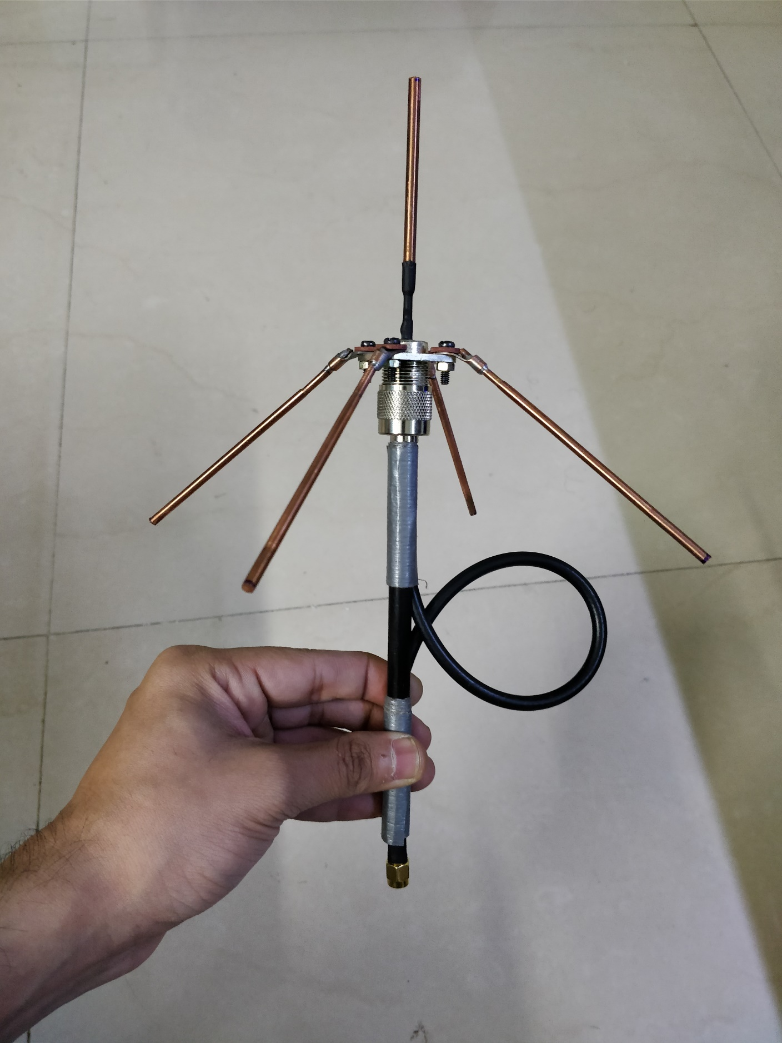

Figure 11 – Sample Antenna Design

# Gantt chart:

# Appendices

# References

1. A. Moreira, P. Prats-Iraola, M. Younis, G. Krieger, I. Hajnsek and K. Papathanassiou, "A tutorial on synthetic aperture radar", *IEEE Geoscience and Remote Sensing Magazine*, vol. 1, no. 1, pp. 6-43, 2013.
2. "Low-power Licence-exempt Radiocommunication Devices — Frequently Asked Questions - Spectrum management and telecommunications", *Ic.gc.ca*, 2018. [Online]. Available: https://www.ic.gc.ca/eic/site/smt-gst.nsf/eng/sf08655.html. [Accessed: 03- Dec- 2018].
3. "Free Space Path Loss Calculator (FSPL) - everything RF", *Everythingrf.com*, 2018. [Online]. Available: https://www.everythingrf.com/rf-calculators/free-space-path-loss-calculator. [Accessed: 03- Dec- 2018].
4. *AN1200.22 LoRa™ Modulation Basics*, 2nd ed. 2015.
5. G. Charvat, *MIT IAP 2011 Laptop Based Radar: Block Diagram, Schematics, Bill of Material, and Fabrication Instructions\**. massachusetts, 2011.
6. “CubeSat,” *CubeSat*. [Online]. Available: http://www.cubesat.org/. [Accessed: 02-Dec-2018].
7. “1-Unit CubeSat structure,” *ISIS - Innovative Solutions in Space*. [Online]. Available: https://www.isispace.nl/product/1-unit-cubesat-structure/. [Accessed: 02-Dec-2018].
8. *Orbital Debris - eoPortal Directory - Satellite Missions*. [Online]. Available: https://directory.eoportal.org/web/eoportal/satellite-missions/c-missions/cubesat-concept. [Accessed: 02-Dec-2018].
9. *Lowpass-filter signals - MATLAB lowpass - MathWorks 中国*. [Online]. Available: https://ww2.mathworks.cn/help/dsp/examples/synthetic-aperture-radar-sar-processing.html. [Accessed: 02-Dec-2018].
10. “Solar Panels X/Y CubeSat Module,” *CubeSat by EnduroSat*. [Online]. Available: https://www.endurosat.com/cubesat-store/cubesat-power-modules/solar-panel_x_y/. [Accessed: 02-Dec-2018].
11. *Texas Instruments*. [Online]. Available: http://www.ti.com/lit/ds/symlink/tms320c5535.pdf. [Accessed: 02-Dec-2018].
12. Www.microchip.com. (2018). [online] Available at: http://ww1.microchip.com/downloads/en/DeviceDoc/PIC32MK-General-Purpose-and-Motor-Control-%20(GPMC)-Family-Datasheet-60001402E.pdf [Accessed 2 Dec. 2018].
13. Semtech.com. (2018). [online] Available at: https://www.semtech.com/uploads/documents/DS_SX1257_V1.2.pdf [Accessed 2 Dec. 2018].
14. Analog.com. (2018). [online] Available at: https://www.analog.com/media/en/technical-documentation/data-sheets/3521fb.pdf [Accessed 2 Dec. 2018].
15. “Defcon 19: build your own radar system « Dangerous Prototypes,” *Dangerous Prototypes*. [Online]. Available: http://dangerousprototypes.com/blog/2011/11/14/defcon-19-build-your-own-radar-system/. [Accessed: 02-Dec-2018].
16. “LTC3521,” *Two Ways to Measure Temperature Using Thermocouples Feature Simplicity, Accuracy, and Flexibility | Analog Devices*. [Online]. Available: https://www.analog.com/en/products/ltc3521.html#product-overview. [Accessed: 03-Dec-2018].
17. *NASA STRATEGIC PLAN 2018*. 2018.
18. *E.coli AntiMicrobial Satellite*. 2015.
19. *NASA Facts: CloudSat*. 2018.
20. "Satellite characteristics", 2015. [Online]. Available: http://www.asc-csa.gc.ca/eng/satellites/radarsat/radarsat-tableau.asp. [Accessed: 03- Dec- 2018].
21. R. Harrington, "Effect of antenna size on gain, bandwidth, and efficiency", *Journal of Research of the National Bureau of Standards, Section D: Radio Propagation*, vol. 64, no. 1, p. 1, 1960.
22. O. Joglekar and L. Communication&nbsp;Gateway, "LoRa Node using Tata Communication Gateway // Omkar Joglekar", *Omkarjr.in*, 2018. [Online]. Available: https://omkarjr.in/posts/projects/LoraTCL/?fbclid=IwAR3GHmh3C-kSGao9jBDLAZrISzuRikJlfpbasY-F88Sno1yggtN14HWX9lg. [Accessed: 03- Dec- 2018].
23. [12]A. Mehrparvar, D. Pignatelli, J. Carnahan, R. Munakata, W. Lan, A. Toorian, A. Hutputanasian and S. Lee, *CubeSat Design Specification*, 13th ed. 2005.